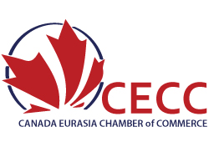
COMPANY COMMITMENT RESPONSE
MMCA and/or KIOGE 2022 Trade Missions

September 19th – 30th, 2022
Almaty, Kazakhstan

We agree to participate:
☐ MMCA Trade Mission: September 19-22, 2022
☐ KIOGE Trade Mission: September 27-30, 2022
☐ In BOTH MMCA and KIOGE Trade Missions: September 29 – 30th, 2022
The Mission(s) Programs will include:
- Walking Access to MMCA 2022 AND\OR KIOGE 2022
- Interpreters
- Business Seminar
- B2B Meetings with identified appropriate company partners
- Reception

Company Name: _________________________________
Company Address: _________________________________________________
Contact Name: __________________________ Contact Email: _______________________
Contact Cell Number: _________________________
Signed:
_______________________________________ ________________________
Name Date

